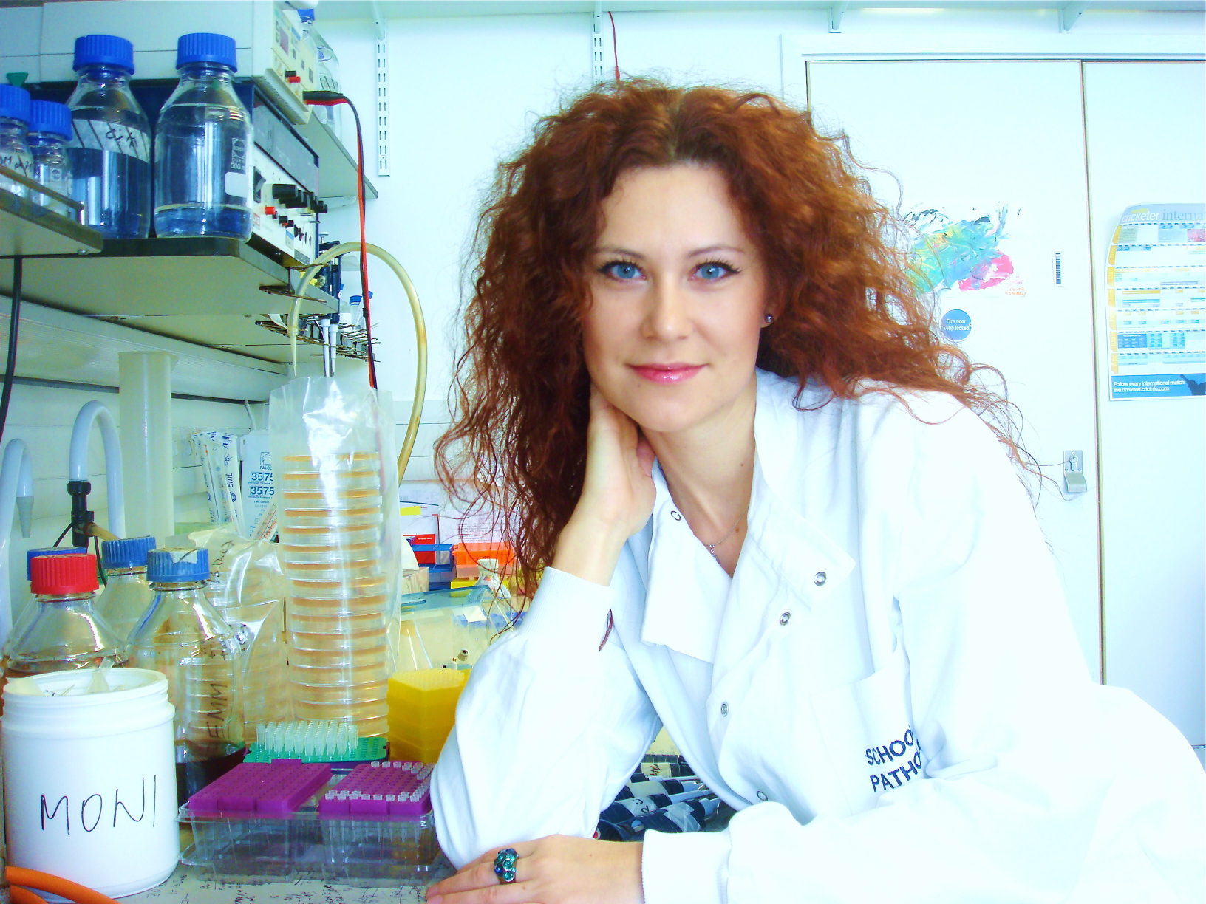

Born: 30.08.1978, Trencin, Slovakia
Nationality: Slovak
Residence: United Kingdom
Current Address: Sir William Dunn School of Pathology, South Parks Road, OX1 3RE, Oxford, United Kingdom
Education
2002-2005 PhD in Molecular Biology, Institute of Medical Biochemistry, Medical University of Vienna, Austria
PhD thesis: An RNA recognition motif containing cyclophilin at the interplay of transcription and pre-mRNA processing

1997-2002 Master (M.S.) in Molecular Biology, Comenius University, Bratislava, Slovakia
Diploma thesis: Testing of gene therapy with retroviral vector expressing bacterial cytosine deaminase gene
(Dean Prize for the best undergraduate thesis)

2009 Master of Art (MA) University of Oxford, honorary title

Employment
2013 Principal Investigator, MRC Career Development Award

2006-20012 Post-Doctoral Research Associate in the lab of Prof. Nick Proudfoot,
Sir William Dunn School of Pathology, University of Oxford

2008 visiting Post-Doctoral fellow in the lab of Prof Mitsuhiro Yanagida,
Kyoto University

2009 visiting Post-Doctoral fellow in the lab of Prof Danesh Moazed
Harvard Medical School, Harvard University

Funding ID
Grants and Fellowships awarded
2008 Oxford University Merit Award

2009 Staines Medical Research Fellowship, Exeter College,
University of Oxford

2009 EMBO short term fellowship, Harvard University

2011 L’Oreal/UNESCO Women in Science Award UK and Ireland

2009-2012 Cancer Research UK Fellowship, Postdoctoral Research Fellow

2012 MRC Career Development Award

Granted International Patent
Gullerova and Proudfoot; Gene silencing induced by convergent transcription in mammalian cells, WO/2012/114111.

Teaching
As a college fellow at Exeter College, Oxford, I had the opportunity to obtain a range of teaching experience. I have tutored (small group teaching of 1-4 students) several degree course models for five years. I am also currently supervising two PhD students.

Public Engagement
I have wide-ranging experience in disseminating information to a popular audience. As The Best Young Scientist of Slovak Republic (2008) and a winner of L’Oreal/UNESCO Women in Science Award UK and Ireland (2011) I have received significant media attention. I have extensive experience with radio and newspaper interviews in both countries, Slovakia and UK. Also, recently I was invited to give a public lecture in Slovakia, which was broadcasted nation wide.
I will continue to engage in information dissemination at general public events.

Awards and Fellowships:
2000 Prize of Czecho-Slovak Society of Microbiology
2001 Dean Prize for the best undergraduate thesis
2008 Sir William Dunn School of Pathology Merit Award
2009 The best young scientist of Slovak Republic 2008
2009 Staines Medical Research Fellowship, Exeter College, University of Oxford
2009 EMBO short term fellowhip, Harvard University
2011 L’Oreal/UNESCO Women in science award UK 2011

Presentations:
2003 8th Annual Meeting of the RNA Society, Vienna, Austria
2003 Wittgenstein symposium, Blumau, Austria
2004 9th Annual Meeting of the RNA Society, Madison, Wisconsin, USA
2004 Annual meeting of Austrian Society for Biochemistry and Microbiology, Innsbruck, Austria
2004 Universidad Internacional de Andalucía (UNIA), Coupling transcription and RNA processing, Beaza, Spain
2005 EMBO workshop: Messenger RNA 3’ ends, Oxford, United Kingdom
2005 Modulators of RNA fate and function II, Vienna, Austria
2007 Fourth International Fission Yeast Meeting, Copenhagen,Denmark
2007 RNA Quality meeting, Aarhus, Denmark
2007 Chromatin structure and function, Antigua
2008 Asian Pacific Fission Yeast Meeting, Singapore
2009 London Chromatin Club Meeting, Abcam
2009 Harvard Medical School, internship 3 months / collaboration
2009 Fifth International Fission Yeast Meeting, Tokyo, Japan
2010 Departmental Seminar, Oxford University
2011 SFB meeting, Vienna, Austria
2011 Theo Murphy International scientific meeting on non-coding RNAs,UK

As an invited speaker:
2008 G0 workshop, Okinawa, Japan
2008 University of Edinburgh
2011 SFB meeting, Vienna, Austria
2012 7th Microsymposium on Small RNAs, May, Basel
2012 MDC's Epigenetics Symposium, March, Berlin
2013 IUPS, Birmingham, UK

Other:
President of Oxford and Cambridge Alumni Society of Slovak Republic

Publications and Citation Number

11. White E., Kamieniarz K., Proudfot NJ and Gullerova M; Human Dicer restricts accumulation of endogenous double strand RNA. Nature, submitted.

10. Schlackow M., Marguerat S, Proudfoot NJ, Bahler J, Erban R and Gullerova M; Functional analysis of 3’UTR in Schizosaccharomyces pombe. Genome Research, submitted.

9. Gullerova M; Genomic Elements in Health, Disease and Evolution, Chapter: Long non-coding RNA, Springer Publishing, in press, 2012 (invited publication)

8. Gullerova M and Proudfoot NJ; Transcriptional gene silencing induced by convergent transcription in mammalian cells. NatStrucMolBiol, in press 2012

7. Gullerova M and Proudfoot NJ; Transcription intereference and gene orientation in yeast: non coding RNA connections. Cold Spring Harbor Laboratory Press, Regulatory RNAs 2011 (1 citation)

6. Gullerova M, Moazed D and Proudfoot NJ; Autoregulation of convergent RNAi genes in fission yeast. Genes and Development, 2011 March; 25 (6) (8 citations)

5. Gullerova M, Proudfoot NJ; Silencing in trans: position matters in fission yeast. EMBO Rep, 2010 March; 11(3):145-6. (invited publication)

4. Gullerova M, Proudfoot NJ; Cohesin complex promotes transcriptional termination between convergent genes in S.pombe. Cell, 2008 March 21; 132(6):983-995. (81 citations)

3. Proudfoot NJ, Gullerova M; Gene silencing CUTs both ways. Cell, 2007 Nov 16; 131(4):649-51. (4 citations) (invited publication)

2. Gullerova M, Barta A, Lorkovic ZJ. Rct1, a nuclear RNA recognition motif-containing cyclophilin, regulates phosphorylation of the RNA polymerase II C-terminal domain. Mol Cell Biol. 2007 May;27(10):3601-11. (3 citations)

1. Gullerova M, Barta A, Lorkovic ZJ; AtCyp59 is a multidomain cyclophilin from Arabidopsis thaliana that interacts with SR proteins and the C-terminal domain of the RNA polymerase II. RNA. 2006 Apr;12(4):631-43. (16 citations)

